Good morrow to you all

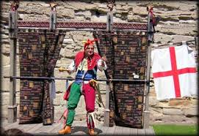

I present to you shows of Juggling Skills and Medieval Magic, and of course plenty of Foolery and Comedy.
I also perform Stories and Jests all from medieval sources.
It may be said that I am the best Medieval Jester anyone has ever seen.

Jonathon de Hadleigh

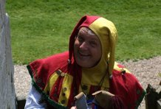

https://www.youtube.com/watch?v=V6xrBTXPDsY

